COYCHURCH HIGHER COMMUNITY COUNCIL

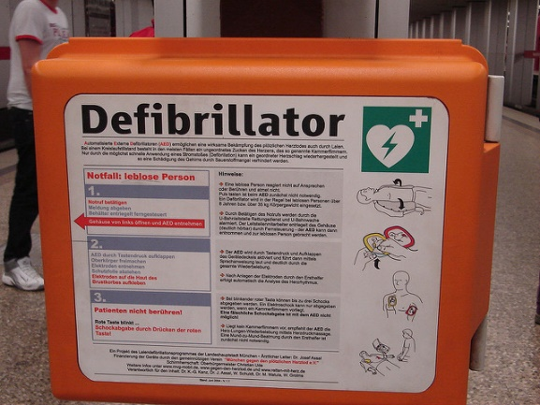

Coychurch Higher Community Council are soon to take delivery of a Defibrillator which will be sited at Heol Y Cyw Welfare Hall.

Would you consider being a First Responder?

First Responders in Wales are volunteers who donate their spare time to attend appropriate 999 calls and provide first hand emergency care to people **in their own community**.

**Could you become a Community First Responder?**

* Do you enjoy a challenge?
* Are you good under pressure and remain calm in an emergency?
* Are you proud of the community in which you live and want to give something back?
* Do you have free time to spare?
* Are you ready to learn essential life-saving skills?
* Have you got a full, clean driving license?
* Are you in reasonable good health?
* Are you over the age of eighteen?

Training is free of charge! If you are interested, please get in touch!

Karyl Carter

Clerk – CHCC

01656 863418

[Clerk2chcc@live.co.uk](mailto:Clerk2chcc@live.co.uk)

Website: www.**community**-**council**.org.uk/**coychurchhigher**